**Science & Agriculture - Grade 5 Term 1 Exams 2023**

**QUESTIONS**

1. Name the digestive system  
   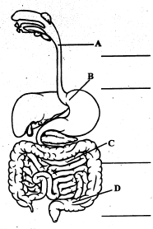
2. Write three invertebrate animal
3. Name two animals that give birth to young ones
4. The digestion of food start in the____ and ends in the_____
5. We use___ to brush our teeth
6. Draw three personal items and name them  
   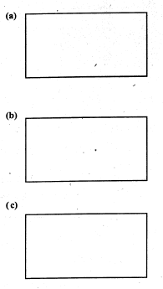

1. Name two external parasites

**AGRICULTURE**

1. What is soil conservation?
2. Name three types of soil
3. Write down three materials required to make compost manure
4. List down three uses of water on a farm
5. Write small animals that clothing crops
6. Draw a scarecrow (2mks)
7. Match the animal with its products  
   cow   wool  
   goat   egg  
   sheep   mohair  
   hen   milk
8. We get water from?

**MARKING SCHEME**

**SCIENCE**

1. 1. oesophagus
   2. stomach
   3. small intestine
   4. large intestine
2. 1. earth worm
   2. files
   3. cockroaches (any insect)
3. 1. cow
   2. dog
4. 1. mouth
   2. small intestine
5. brush, water
6. (any)
7. 1. bedbugs
   2. ticks (any other)

**AGRICULTURE**

1. Soil conservation is practice of using water efficiently to reduce unnecessary water usage
2. 1. loam
   2. clay
   3. sand
3. 1. dry grass
   2. ashes (any)
   3. top soil
4. 1. watering crops
   2. washing tools
   3. mixing chemicals
5. 1. Monkey
   2. Squirrel
7. Cow - milk  
   goat - mobair   
   sheep - wool  
   hen - ege
8. rain